**Jenkins Pipeline Understanding document**

**Link :** <https://www.youtube.com/watch?v=s73nhwYBtzE&t=398s>

1. First create one automation project and push it to either Bitbucket or GitHub
2. Create one Jenkinsfile (**Declarative** Pipeline) with below content and push this to BitBucket ot Github

Note : We do not need Jenkinsfile for **scripted** pipeline as we are writing directly in Jenkins)

pipeline{

agent any

stages {

stage('Compile Stage'){

steps {

bat 'mvn clean compile'

}

}

stage('Test Stage'){

steps {

bat 'mvn test'

}

}

}

}

**Note**: Use bat for windows OS and sh for Linux OS.

1. Open the Jenkins 🡪 Click on New Item 🡪 Enter the new item name and select the pipeline and then click on ok button.

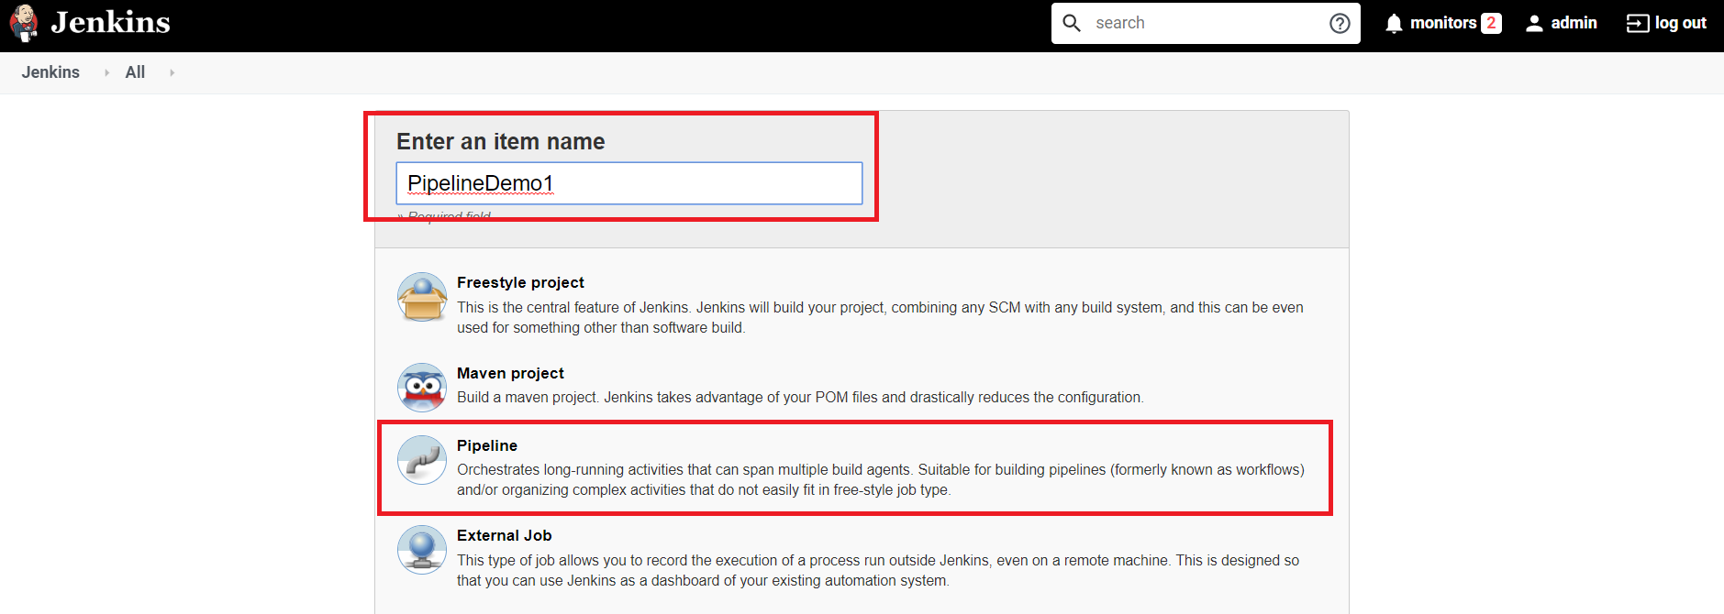

1. Click on configure and do the below mentioned changes then click on apply button.

Repository URL : <https://deepak_applabs@bitbucket.org/deepak_applabs/pipelinedemo.git>

Credentials : deepak.applabs@gmail.com/Ainesh*005

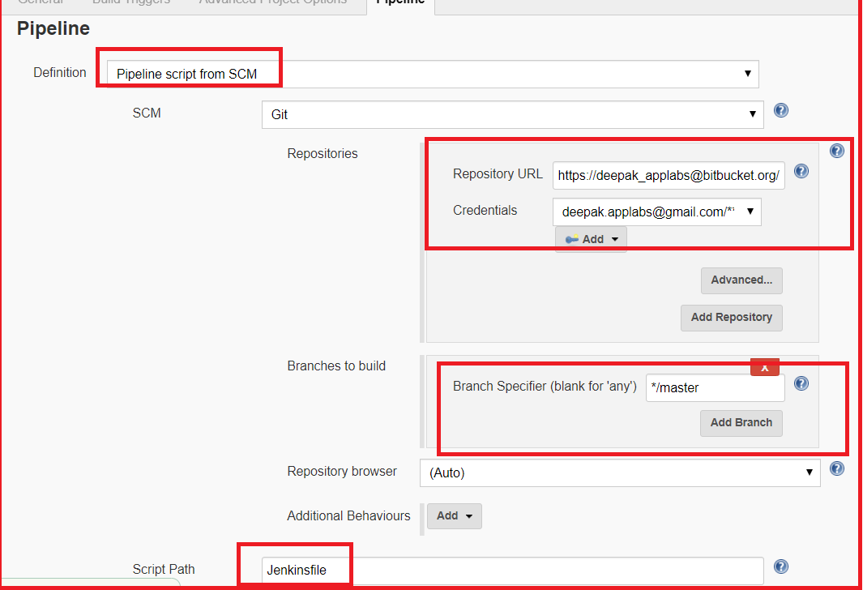

1. Then click on Build now

Link : <https://www.youtube.com/watch?v=_fmX31VFbL8>

Time : 24:59

One more example of Jenkins file for the creation of declarative pipeline

pipeline{

agent : any

Stages {

stage(‘one’)

{

Steps

{

Echo ‘ Hi, I am Deepak ‘

}

}

stage(‘two’)

{

steps

{

input ‘ Do you want to proceed ‘

}

}

Stage(‘three’)

{

when

{

not

{

branch ‘master’

}

}

Steps

{

echo ‘ Hello’

}

}

Stage(‘four’)

{

parallel

{

stage(‘unit test’)

{

Steps

{

echo ‘ Running unit test’

}

}

stage(‘Integration Test’)

{

Agent

{

Docker

{

reusable false

Image ’ubantu’

}

}

Steps

{

Echo ‘ Running integration test’

}

}

}

}

}

Link :: <https://www.youtube.com/watch?v=LFkGtg-ZTko>

